

10/31/2024

**SUBMITTED BY: ANIYA FATIMA**

**SAP ID: 66375**

**DEPARTMENT: CYBER SECURITY**

**SEMESTER: 1ST**

**SUBMITTED TO: MA’AM FAREEHA**

PROGRAMING FUNDAMENTAL

LAB TASK#8

**QUESTION N0 1:**

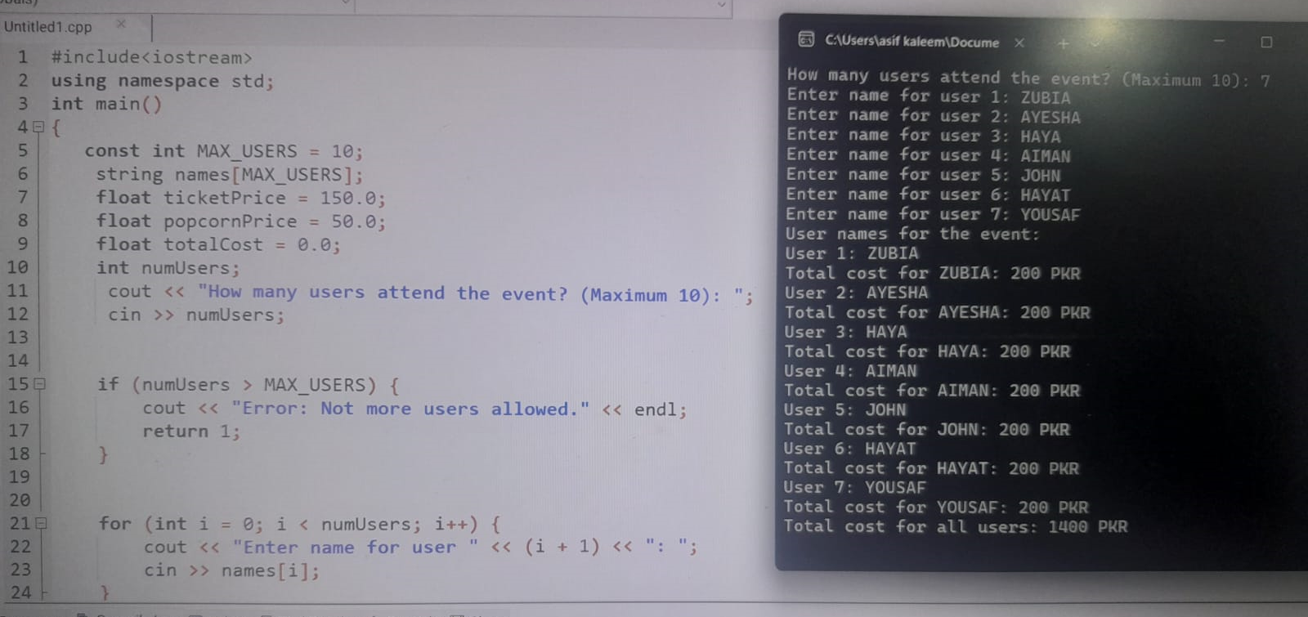

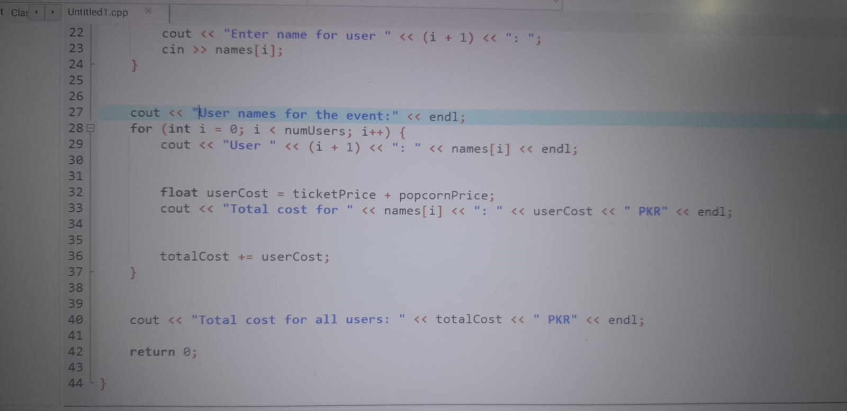

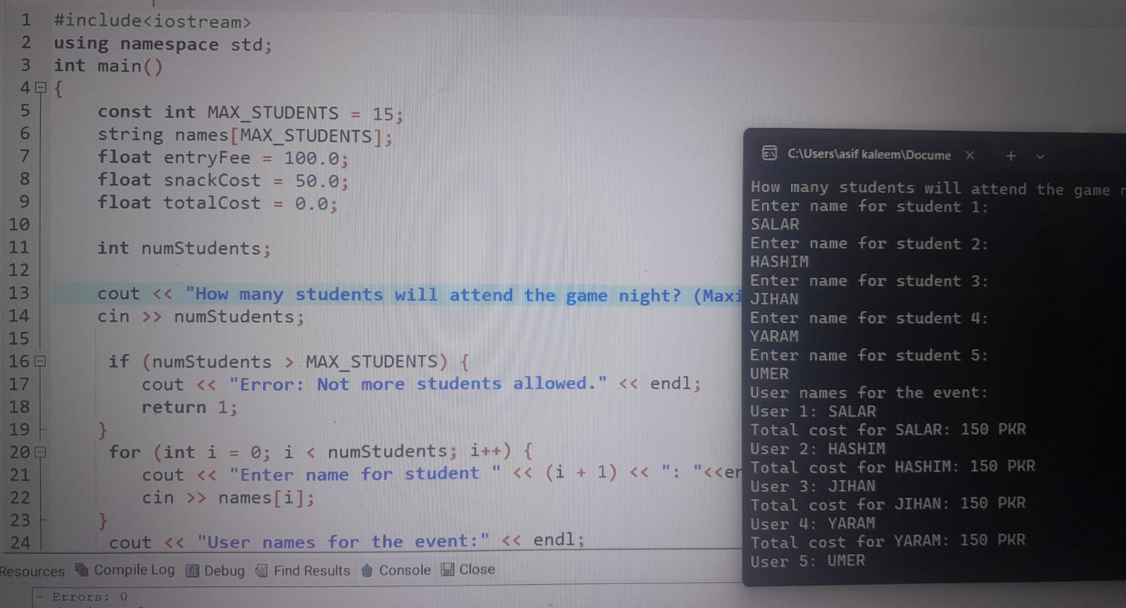**QUESTION NO 2:**

